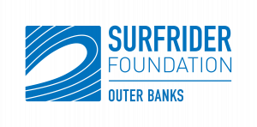
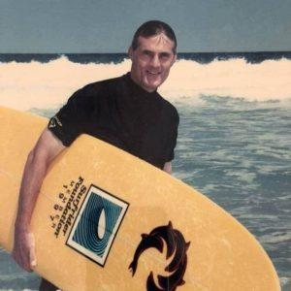
Surfrider Foundation Outer Banks Chapter
Larry Gray Environmental Sciences Scholarship Announcement
$1,000 for each Scholarship
Our chapter is dedicated to protecting our local ocean, waves, beaches, waterways, and engaging the next generation of coastal defenders.
Larry went on to help inspire a generation of surfers on the Outer Banks. He traveled the world in search of surfing hot spots and in pursuit of that perfect wave, bringing home stories that others would go on to emulate. During the mid-1970s he lived for two winters on the famous Hawaiian North Shore, surfing Sunset Beach alongside legendary surf icon Eddie Aikau. Perhaps one of his biggest achievements in the world of surfing came in 1970, when he won the Cape Hatteras Lighthouse Centennial Surf Competition, performing a perfect front-side 360 during his set to edge out the challengers. His brothers Tony and Ronnie say that some of their own best moments while surfing were alongside their Big Kahuna brother Larry.
Larry’s love of running led him to organize the first annual Nags Head Woods 5K Run in 1982. A major goal of the race was to allow folks from all walks of life to experience the beauty of the Nags Head Woods and hopefully turn their eye toward its preservation. The Nature Conservancy Nags Head Woods Preserve is a regular beneficiary of a portion of the run’s profits. In 1996, a Coastland Times article said of Larry that the “tone of the run might be said to be an extension of his personality.”
In addition to starting the 5K, Larry’s love of conservancy, athleticism, and surfing led him to help found the Outer Banks Chapter of the Surfrider Foundation in 1993. An organization that still helps preserve these shores to this day, the Surfrider Foundation has taken on issues such as water quality and offshore energy while striving to give back to the community via scholarship programs and beach clean-ups. Larry also pursued other conservation efforts by serving as a board member for the Nags Head Woods Preserve and, early on in his professional career, as a park ranger for the Cape Hatteras National Seashore (U.S. National Park Service).
Therefore, the Outer Banks Chapter of the Surfrider Foundation is proud to offer and award at least one scholarship to individuals who are planning to pursue a Bachelor’s degree in an environmental/natural science field.
Applicants must meet the following criteria to be eligible for consideration:
- Must be enrolled in a Dare County High School
- Must be a current high school senior
- Preference will be given to individuals who are pursuing a career in an environmental science or a natural science profession such as Environmental Science, Natural Resources, Rangeland Management, Environmental Policy, Fish or Wildlife Management, Biology, Botany, Zoology, or other related fields.
- Have demonstrated interest or activities related to environmental or natural sciences.
- It’s a plus to have interests in surfing, kayaking, and the enjoyment of the ocean.
- Along with each scholarship, a 1-year membership to the Surfrider Foundation will be awarded.
Surfrider Foundation's Mission: A powerful activist network dedicated to the protection and enjoyment of the world’s oceans, waves and beaches.
In loving memory of Larry Gray
An ocean warrior, loving community member and dedicated Surfrider.
Your memory lives on in Surfrider Foundation.
Rest in Peace.
You will forever be in our "memory bank"
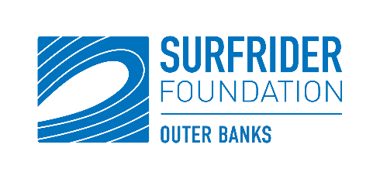
The Outer Banks Chapter of the Surfrider Foundation
Scholarship Application – 2021
Name________________________________________________________________________
Last First Middle (if applicable)
Address_______________________________________________________________________ Phone________________________________________________________________________
City______________________________County_______________State_______Zip__________
Number of years as a resident of Dare County ______________________________________________________________________________
Name of School currently enrolled at ______________________________________________________________________________
How many years? ______________________________________________________________________________
Name and location of college(s) you plan to attend ______________________________________________________________________________
______________________________________________________________________________
Have you applied to this college(s)? ______________________________________________________________________________
Have you been accepted by this college(s)? ______________________________________________________________________________
Major(s) you plan to Pursue: ______________________________________________________________________________
Extra-curricular activities you Enjoy: ____________________________________________________________________________

School activities you Enjoy: _____________________________________________________________________________
Community activities you Enjoy: ____________________________________________________________________________
Awards you have Received: _____________________________________________________________________________
Work Experience (paid or volunteer):
_____________________________________________________________________________
Are there any special circumstances concerning you that would aid us in making a
Decision? If so, please describe these: ____________________________________________________________________________________________________________________________________________________________
Two references we may contact:
Name __________________________________ Name ________________________________
Phone __________________________________ Phone _______________________________
Relationship _____________________________ Relationship __________________________

This application must be accompanied by:
- a complete high school or college transcript
- an essay of at least 500 words describing specifically why you are interested in the natural science field listed on your application.
- Please also include a letter of recommendation by someone other than a family member.
All applications must be received by deadline provided by school counselors’ office, 2021.

Applicant’s Signature (Initial)_____________________________ Date___________________
- Complete an essay below of at least 500 words describing specifically why you are interested in the natural science field listed on your application.

