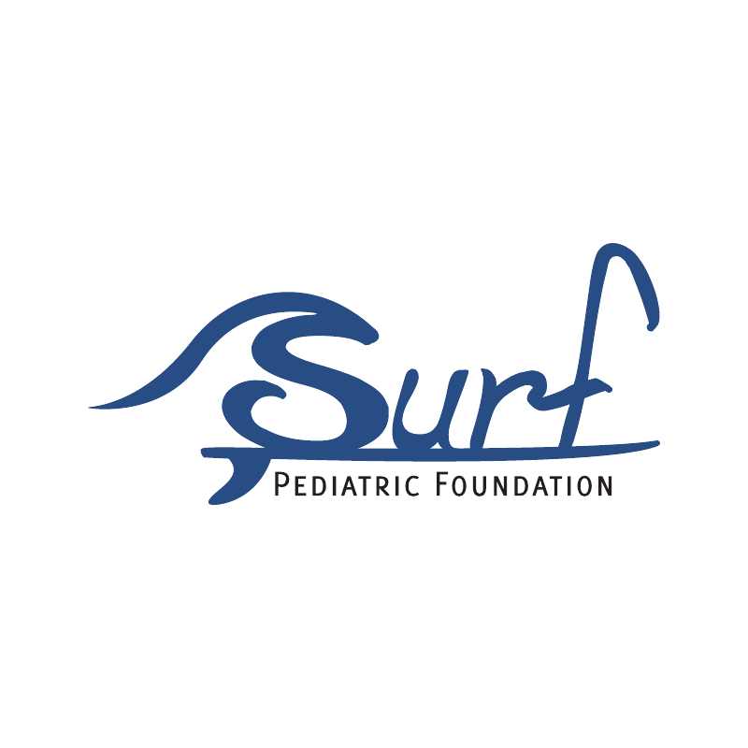
SURF PEDIATRIC FOUNDATION (SPF) SCHOLARSHIP

The Surf Pediatric Foundation Scholarship is designed for the 2021 graduating seniors in the local community, including Dare County and Currituck County schools. This scholarship will be offered to a high school senior who will be pursuing an education and/or occupation in the healthcare field. A $1,000 scholarship will be given to one high school senior from each of the following schools: First Flight High School, Manteo High School, Cape Hatteras Secondary School and Currituck High School. This scholarship is not renewable.

Selection criteria:

1. Must be a high school senior

2. Must plan to pursue a healthcare-related field and/or occupation

3. Must be enrolled in Dare County or Currituck County School

4. The award is based on:
Scholastic standing, (3.0 GPA or higher)
Community and Scholastic Achievement
Leadership Qualities
Recommendation and Essay/Answer

Packet Includes:

1. Application Form

2. Resume including school organizations, athletics, and activities you have participated in; any honors you have received during high school years; work and volunteer experience, especially related to future career goals; and involvement in community activities

3. 2 Letters of recommendation

4. Unofficial transcript (or equivalent)

5. One page, single spaced, typed essay that responds to each of the following questions:
- Your motivation for your chosen career/occupation and/or future academic studies
- What life lessons have you learned during the COVID-19 pandemic?

SCHOLARSHIP APPLICATION FORM

(Attach additional pages to this application as needed)

APPLICANT’S NAME:

ADDRESS:

DATE OF BIRTH:

HOME PHONE #: ______________________ CELL #: ________________________

E-MAIL ADDRESS: ____________________________________________________
STUDENT LIVES WITH:
FATHER/GUARDIAN’S NAME:
ADDRESS (IF DIFFERENT FROM APPLICANT):

TELEPHONE NUMBER:
FATHER’S EDUCATION:
FATHER’S EMPLOYMENT WITH ADDRESS & TELEPHONE #:

MOTHER/GUARDIAN’S NAME:
ADDRESS (IF DIFFERENT FROM APPLICANT):

TELEPHONE NUMBER:
MOTHER’S EDUCATION:
MOTHER’S EMPLOYMENT WITH ADDRESS & TELEPHONE #:

SCHOLARSHIP APPLICATION FORM

NAME(S) OF HIGH SCHOOL(S) ATTENDED:

CLASS RANKING THROUGH FIRST
SEMESTER OF SENIOR YEAR:

CUMULATIVE GPA THROUGH
FIRST SEMESTER OF SENIOR YEAR:

BEST SAT SCORE: CR: MATH: TOTAL:
BEST COMPOSITE ACT SCORE: ____________ (Can provide 4 breakdowns, if desired)

LIST COLLEGES/TECHNICAL SCHOOLS APPLIED TO (Note: Please state if you have been accepted and if you have decided where going):

YOUR ANTICIPATED MAJOR (Mandatory):

LIST OTHER SCHOLARSHIPS APPLIED FOR:

The information given on this form is true and accurate to the best of my knowledge.

Applicant’s Signature (Initialed) Date

Parent/Guardian’s Signature (Initialed) Date

One page, single spaced, typed essay below that responds to each of the following questions:
- Your motivation for your chosen career/occupation and/or future academic studies
- What life lessons have you learned during the COVID-19 pandemic?

