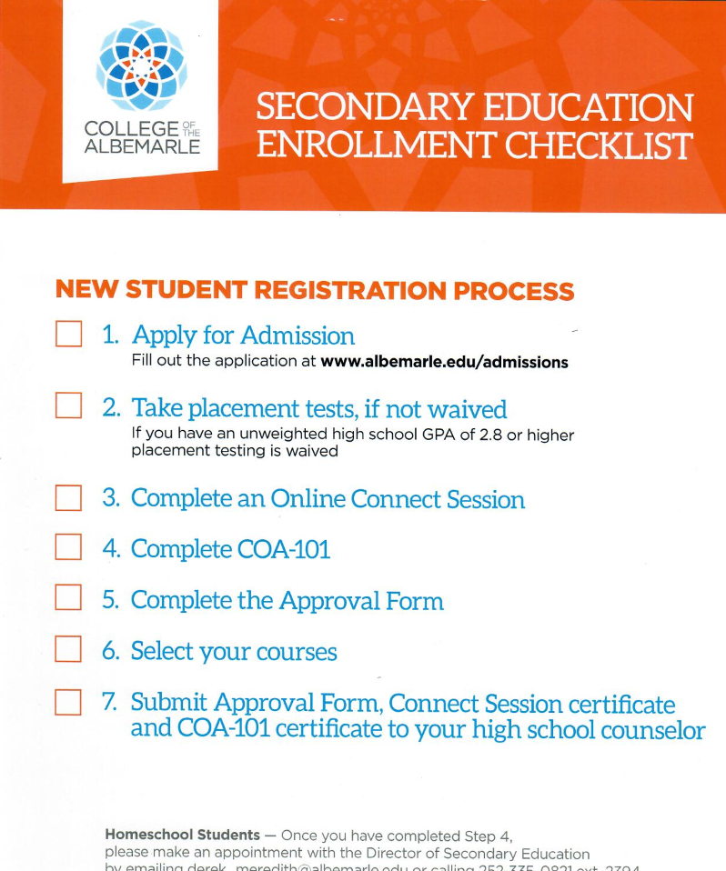
Submit your electronic form and then email your certificates to Mr. Hunting at huntingjo@daretolearn.org

College of The Albemarle Dual Enrollment Information and Tips
CCP Enrollment Meeting- February 23rd @ 1pm on zoom: https://zoom.us/j/99476837508.

Placement Testing
Students who do not meet the GPA requirement of 2.8 unweighted GPA must demonstrate college readiness by earning the required score on an approved assessment. Approved assessments include the Pre-ACT, ACT, PSAT, SAT and the college placement test (RISE). Students can take the placement test at the Dare campus of COA. The placement test is offered on Wednesdays and Thursdays from 9am-3pm. Students must start the exams at least 3 hours before testing center closing time. Students will be required to take the Reading/Writing and Math sections of the placement test and place into the college level to have access to dual enrollment classes. Students are only able to take the placement test 2 times in a 10-year period. Students interested in testing should email katie_cross@albemarle.edu
COA Admissions Application
The COA admissions application can be found on the COA webpage: www.albemarle.edu under Apply and Register.

Need help with your application? Join Mr. Hunting on 2/24 @ 1pm via google meets: meet.google.com/yar-eosh-zhm

- Students will be prompted to create a CFNC account. In creating that account the role should be listed as High School Student. Students should write down their log in information in case they must revisit their application.
- Once logged in students must complete the fields with an * asterisk. However, we do recommend that students complete all the questions on the application. For each page, once all the information that is required is entered, a will appear on the left hand tool bar.

- The Name and Address page will require students to submit the following information:
  - Name permanent address telephone number
email address country permanent mailing address

- The Personal Information Page will ask students to enter:
  - date of birth gender ethnicity
SS# citizenship driver’s license information military service information
  - Students should enter SS# for tax purposes. PLEASE ENTER Social Security #
  - If a student answers YES to having a driver’s license they are required to provide the issuing state, driver’s license number and the original date issued

- On the Enrollment Information page students should select FALL 2021 as their start term and select Career and College Promise as their Entrance status.
  - Under Career and College Promise Pathways students will select either CTP or CTE.
  - If you don’t know – pick CTP.
    - College Transfer Pathway (CTP)
    - Career and Technical Education Pathway (CTE)
      - Students who chose CTE should answer YES that they plan to be a CTE concentrator.
    - CTP and CTE Program of Study is Dual Enrollment- High School
    - In most cases students plan to enroll part time (less than 12 credit hours)
    - Students should select their campus location (Dare) and the other general enrollment questions.

COA Admissions Application Continued

- Educational Information page will require students to enter their high school information and Education History. Student should enter: First Flight High School as their high school.
- The last date attended is your expected graduation date (example: June 2022)
- Students should select that they are current high school students.
- If a student is asked for an RDS number they should go back to the Enrollment Information page and correct their entrance status. Their entrance status should be Career and College Promise NOT freshmen.

Student should enter their name on the Student Statement Page and SAVE and SUBMIT THE APPICATION.

Activate Account
Once your application has been processed, which is generally within 48 business hours each student will receive an email from COA to the email they listed on their application with their username and student ID number. Students should write this information down as it will be needed throughout their time at COA. Students will also be sent directions on how to activate their account. I have also attached information on how to activate your COA account. Students will need to activate their account to complete the following steps. Students should write down their username, password and student ID number.

Connect Session
Students will be required to watch and complete the online Connect Session. Once you have activated your account, go to www.albemarle.edu sign into mycourses. To watch the Connect Session students should click on the Connect Session and follow the directions. Students must log in to their mycourses and watch the connect session for the system to recognize the competition of this requirement. Please print the certificate once you have watched the Connect Session. This certificate will have to be submitted with your approval form.

Complete COA -101
Prior to being enrolled in courses students must access and complete COA 101. COA 101 is a set of six modules and quizzes offered through the mycourses system. Once a student has created their account, students can access COA 101 by logging into mycourses from the COA webpage of www.albemarle.edu. Students will have to complete the six modules and earn at least a 90% on each of the module quizzes to earn their certificate. Upon completion of all the modules and quizzes, students must print the COA 101 certificate to submit as part of their enrollment packet. Here are a few things to remember and a few tips in assisting you complete COA 101:
M1: As a general rule student should study 2-3 hours on homework for every credit hour of classes they are enrolled in. Students should also seek to problem solve on their own before seeking assistance. COA’s learning management system is Moodle and remember classes are available in Mycourses the 1st day of class!
M2: Pay attention to the course structure and how to calculate your grades. Also remember you are permitted customize your mycourses dashboard (including a picture).
M3: Pay attention to the different sections of mycourses and the different communication methods used in mycourses.
M4: Be sure to understand the various discussion forum and assignment types.
M5: Webex session are only set up by instructors and students must log into webex during the semester if in a webex class. This is a short section be sure to read about webex!
M6: Complete the mycourses course evaluation and print the certificate!

Submission of Forms and Enrollment
Student must submit their completed and signed approval form, the Connect Session and the Mycourses 101 certificates in order to be enrolled in CCP Classes. Due to COVID 19 approval forms are electronic and require students to play an active role in the submission on their form. Please review the attached directions on how to complete the electronic form. Once students complete the above steps and have the Secondary Education Approval form completed and signed by their parents, they can email their COA 101 and Connect Session certificates to Mr. John Hunting (huntingjo@daretolearn.org) their enrollment packet will be submitted to the COA HS Liaison who will enroll students into COA classes.

Not sure which courses you can take or which pathway to pursue? Check out the CCP website: https://www.albemarle.edu/apply-register/degree-seeking-credit-students/high-school-students/

First Flight High School Career and College Promise Enrollment Deadlines

February 17th @ 6pm: CCP Parent Meeting via zoom https://zoom.us/j/99809590991

February 23rd @ 1pm: CCP Student Informational Meeting via zoom. This meeting is for all students new to CCP and COA. https://zoom.us/j/99476837508

February 24th @ 1pm: COA Application Help Session via Google Meets. This meeting is for students new to CCP who need help with their application. meet.google.com/yar-eosh-zhm

March 12th @ 1pm: Returning CCP Advising Session via zoom This meeting is for all currently enrolled CCP students. https://zoom.us/j/92758575843

March 22nd : Due date of approval forms for priority registration. New CCP students must also submit their COA 101 and Connect Session Certificates to Mr. Hunting to be enrolled.

April 30th: Final deadline for acceptance of Fall 2021 CCP forms. Students who do not submit their information prior to 4/30 will NOT be registered for COA courses for fall 2021.

Have questions? Need Help? Stop by our virtual office hours!
John Hunting: Monday-Thursday 1:00-2:00pm March 1st- April 30th
meet.google.com/yar-eosh-zhm

Katie Cross: Tuesdays 2:00-3:00pm March 9th- June 8th
meet.google.com/ryo-kqhw-kpu

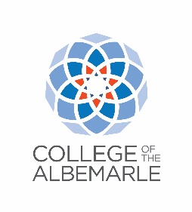

2021-2022 Online CCP Approval Form Instructions
After completing your COA Admissions Application, Connect Session and COA-101 Course; complete the “2021-2022 Online CCP Approval Form.” This form MUST be completed and signed by the student and signed by a parent.
Student Instructions:
Step 1 – Click on the link provided to you to access the docusign
https://na2.docusign.net/Member/PowerFormSigning.aspx?PowerFormId=560d3bc0-c2e3-402e-bbb4-cd2edfce1f9e&env=na2&acct=24a3d64a-8a4f-41f4-bacb-5bccbaefd825&v=2
Step 2 – Enter Student’s Full Name and Email Address under Student.
Step 3 – Enter Student’s Parent/Guardian Full Name and Email Address under Parent/Guardian.
Your high school advisor and COA liaison information is already entered. Do not change this information.
Step 4 – Click “Begin Signing” (Orange button at the bottom of the page)
Step 5 – Click “Got It”
Step 6– Click “I agree to use electronic records and signatures” (In the top left corner)
Step 7 – Click “Continue” (top right corner)
Step 8 – Click “START”
Step 9 – Check your selected pathway. Remember the classes you select must be on your pathway. Need more help on selecting a pathway and seeing which courses are permitted on each pathway? https://www.albemarle.edu/apply-register/degree-seeking-credit-students/high-school-students/
Step 10 – Scroll down and enter your classes for fall 2021. You can list up to 6 courses under Fall 2021 Example: PSY 150, ENG 111, ART 111, BIO 111, HIS 132 If you need help selecting courses students should consult their HS guidance counselor or attend Mr. Hunting’s or Mrs. Crosses office hours. Links can be found at the end of this document.
Step 11 – Enter your first and last name in the Student’s Name Box
Step 12 – Click the Yellow sign arrow to sign the form electronically (you will be given an option of a signature)
Step 13- Click “Adopt and Sign”
Step 14 – Enter your birth date (month/day/year)
Step 15- Enter your Unweighted High School GPA and your social security number (if not on application)
Step 16- Enter the year you will be in 2021-2022 (next year)
Step 17- Click “Finish”

Your Parent/Guardian will then get an email directing them to DocuSign to complete their portion of the form. This email will be sent to the email you listed in the beginning on the process
Parent Instructions:
Step 1 – Open email from Derek Meredith (Please DocuSign: CCP Approval Form 21-22) (Note: please do not reply to Derek Meredith)
Step 2– Click “Review Document” (middle of page orange button).
Step 3-– Click “I agree to use electronic records and signatures” (In the top left corner)
Step 4 – Click “Continue” (Orange button in the top right).
Step 5- Click “Start”
Step 6 – Click “Sign” (Yellow button above signature line)
Step 7 - Click “Adopt and Sign”
Step 8 – Click “Finish” (Orange button at the bottom of the page)
Step 9 – You have the option to download, print or close. Choose what you would like to do.
The form will automatically be sent to the High School and then COA.
Have questions? Need Help? Stop by our virtual office hours!
John Hunting: Monday-Thursday 1:00-2:00pm March 1st- April 30th
meet.google.com/yar-eosh-zhm

Katie Cross: Tuesdays 2:00-3:00pm March 9th- June 8th

Virtual Office Hours

Katie Cross
Tuesdays
2:00-3:00pm
Google Meets
March 9th-June 8th
meet.google.com/ryo-kqhw-kpu

John Hunting
Monday-Thursday
1:00-2:30pm
Google Meets
March 1st-April 30th
meet.google.com/yar-eosh-zhm

Having Trouble with your application, connect session, mycourse COA 101 or activating
your account? Pop in to a virtual office hours or
Contact John Hunting at
john_hunting07@albemarle.edu
or
huntingjo@daretolearn.org

